Chapter 16, Problem 45.

Find v(t) for t > 0 in the circuit in Fig. 16.68.

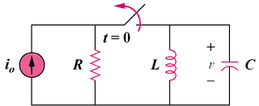

Figure 16.68
For Prob. 16.45.

